Template guidance | Recommended Template
Style guide | Style Guidance
Breadcrumb | Home > Publications > Departmental memoranda > D10

Memorandum D10-15-28 - Tariff Classification of Footwear, Covering the Ankle
ISSN 2369-2391
Ottawa, month day, year
This document is also available in PDF (701 KB)

Plain language summary

Targeted audience: importers of commercial goods
Key content: Provides an outline of the CBSA’s administrative tariff classification policy of footwear, covering the ankle.
Keywords: footwear, shoes, boots, ankle, covering the ankle

On this page
- Updates made to this D-memo
- Definitions
- Guidelines
  - Additional Information
- Appendix
- References
  - Applicable legislation
  - Related D memoranda
  - Issuing office
- Contact us

Updates made to this D-memo
This D-memo has been updated to reflect accessibility and plain language considerations.

Definitions
1. This memorandum provides guidance for interpreting the term "covering the ankle", as found in Chapter 64 of the Customs Tariff (Tariff).

2. The Section and Chapter Notes in the Tariff offer no definition of either "covering" or "ankle". Likewise, the relevant Explanatory Notes offer no clarification. In the absence of clarity in the relevant notes, the following dictionary definitions of the terms will be used.

Ankle: the joint connecting the foot to the leg, marked by the projections (malleolar zone) formed on the outside by the fibula, on the inside by the tibia.

Covering: a thing used to cover, protect or conceal something else

Guidelines

3. For tariff classification purposes, the ankle is the area of the ankle joint where the leg and foot join – commonly called the "ankle bone" and anatomically referred to as the "malleolar zone" (refer to Appendix figure 1).

4. The foot portion of the ankle joint includes the midfoot (arch) – made up of the Navicular, Cuboid and Cuneiforms bones, and the hindfoot (heel) – made up of the Talus and Calcaneus bones. The lower leg portion of the joint consists of both the tibia and fibula bones (refer to Appendix figure 2).

5. In order to satisfy the terms of "covering the ankle", the footwear upper must provide 100% coverage of the midfoot, hindfoot and malleolar zone.

6. Partial coverage of the midfoot, hindfoot and malleolar zone, no matter how large or small, does not satisfy the terms of “covering the ankle”.

7. Footwear with straps, ties, lacing, buckles, ribbons or ornamental trimmings, readily identifiable as part of the upper and designed to be positioned anywhere on the ankle, but not providing 100% coverage of the midfoot, hindfoot and malleolar zone, does not meet the terms of “covering the ankle”.

8. Footwear that features an upper with cut-out or punch-out shapes or patterns that expose the midfoot, hindfoot or ankle joint area does not meet the terms of "covering the ankle".

9. Footwear that is considered to cover the ankle, as described above, but is designed with open toes, which mean that the wearer’s toes (phalanges) are not covered, are classified under a "covering the ankle" subheading.

Additional Information

10. Procedures to obtain an advance ruling for tariff classification of goods are outlined in Memorandum D11-11-3: Advance Rulings for Tariff Classification.

Appendix

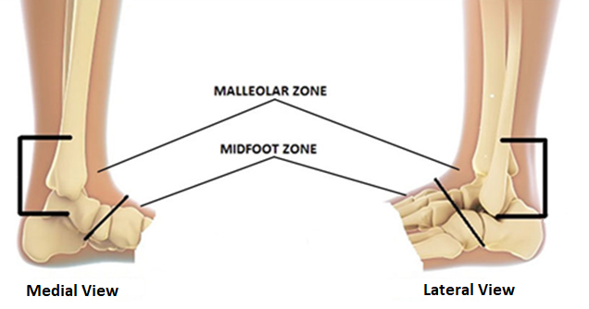
Figure 1: One image containing two pictures of the bone structure of the human ankle joint. The joint is shown to cover the area where the leg and foot join, anatomically referred to as the "Malleolar Zone". Picture on the left shows the medial view and the picture on the right shows lateral view of the same ankle joint. In the middle of the image there are lines pointing to the section of the foot in each view that represents the malleolar zone and the mid foot zone respectfully.

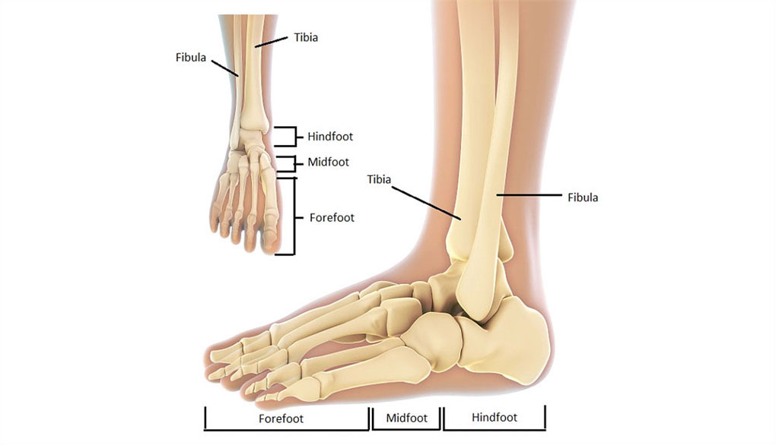
Figure 2: One image containing two pictures of the human ankle joint that illustrates and identifies the different parts of the foot from different viewpoints: Tibia and Fibula bones; Forefoot, Midfoot and Hindfoot. Picture in the top left is a view of the top of the foot. The larger picture on the right is a side view of the same foot.

References
Consult these resources for further information.

Applicable legislation
- Customs Tariff

Related D memoranda
- D11-11-3: Advance Rulings for Tariff Classification

Issuing office
Tariff Classification, Origin and Valuation Division
Trade Programs Directorate
Commercial and Trade Branch

Contact us
Contact border information services

Metadata table
Description | This memorandum outlines the CBSA’s administrative tariff classification policy of footwear, covering the ankle.
Subject | Policy; Trade; Border Crossing; Customs and excise
Keywords | Departmental memoranda, memorandum, legislation, footwear, ankle, shoes, covering the ankle
Content owner | Canada Border Services Agency > Commercial and Trade > Trade and Anti-dumping Programs > Trade Policy > Tariff Policy Unit A

