How to Install EICS v.2.35.0’s CAB File
(Effective June 28, 2020)
Because of the new CAB file’s new signature, the user will be presented with about 80 dialog boxes such as illustrated below when installing EICS v.2.35.0’s CAB file.
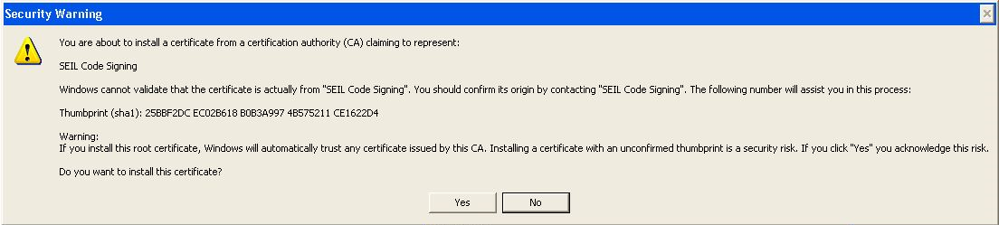
It is perfectly acceptable to click “Yes” on all the dialog boxes, after which, EICS v.2.35.0’s CAB file will download and install as usual.
Alternatively, if the user wishes to avoid clicking on the dialog boxes, do the following before launching EICS-SCEI Direct:
How to Remove CAB Files
Administrator privileges are required.
- Look for C:\Windows\Downloaded Program Files\ Export Import Control System, right-click on it and select Remove. This is the CAB pointer which was downloaded on first login.
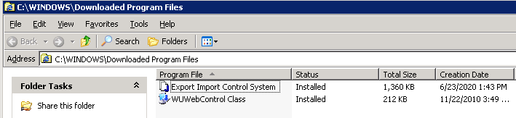
- Go to C:\Windows\Java\Packages and remove the zip file having the size approximately 1.3MB (naming convention uses random names) and a date close to the EICS CAB pointer; see screen shot below
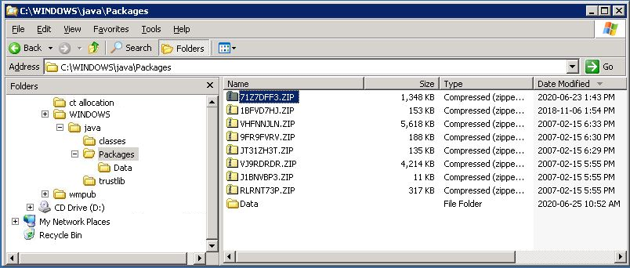
- Log in to EICS-SCEI Direct; you should receive the prompt to download the eics.cab file (if other security settings allow this to pass transparently, the normal <Please Wait> should eventually give way to Menu Bar visibility)

